Referral Criteria for Saint Catherine’s Fee for Service Non-Cancer Related Lymphoedema and Lipoedema Service

Lymphoedema occurs because of the lymphatic system failing to control the fluid equilibrium in the tissue spaces and as a result swelling or oedema develops. It can affect any part of the body and is classified as either Primary Lymphoedema, where the oedema occurs because of a congenital abnormality, or Secondary Lymphoedema, a normally functioning lymphatic system becomes damaged and fails to act due to extrinsic factors such as infection, trauma, and disease.

Lipoedema is a life-long condition characterised by an accumulation of adipose tissues to the buttocks, thighs, and lower legs. Sometimes it presents in the arms. Symptoms include pain or discomfort and bruising. Lipoedema can affect overall quality of life which includes impact on psychological wellbeing, social connections, and physical capabilities; walking may be impaired.
Lymphoedema and lipoedema do coincide.
Risk factors for the development of lymphoedema:
• Genetic predisposition/ family history of chronic swelling
• Chronic venous insufficiency
• Limited mobility or reduced limb function
• Trauma to lymph nodes/ pathways
• Chronic skin disorders
• Recurrent soft tissue infections in the same site such as cellulitis and chronic inflammatory changes
• Vascular or vein grafting surgery
• Lymphadenopathy
• Obesity or morbid obesity
• Filariasis

Consider:
• If the swelling occurred suddenly, exclude thrombosis.
• Patients diagnosed with thrombosis will be assessed and management modified as appropriate based on assessment.
• Patients who currently have an acute cellulitis. Please refer to www.thebls.com/documents-library/hcp-postcards
• Presence of arterial disease. If known or suspected, please refer to vascular specialist for further advice and/or consent regarding future lymphoedema management.

Contraindications:
• Recent surgery and resulting oedema. This can last up to 8 weeks. Monitor as may resolve spontaneously.
• ABPI < 0.6(consider referral for vascular assessment).
• Unstable cardiac/renal failure.

Ineligibility Criteria:

•Patients with venous ulceration will only be accepted by the clinic at the request of the Tissue Viability Nurse or a Vascular or Dermatology Consultant once healing has occurred and skin is intact.
• Patients with Morbid Obesity/Severe Obesity/Grade 3 Obesity i.e., with a BMI >40, will not benefit from lymphoedema therapies. Obesity should be managed by diet and exercise or referral for more active management. Patients who commit to a program of obesity management, evidenced by recent weight loss of at least 3kg or reduction in waist measurement of 3cms, will be assessed by the team as to the appropriate time to initiate lymphoedema treatments.

Please email this form to
sch.referral@nhs.net
Telephone number: 01723 351421
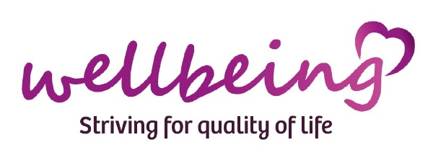

 | Saint Catherine’s Fee for Service Non-Cancer Related Lymphoedema and Lipoedema Referral Form
Referral Date: NHS No: |  | Person Taking referral:
Name: Mr Mrs Miss  Address:  Postcode: Tel No.  D.O.B. |  | Referrer: Contact Details:  GP (if different from above)  Address: Tel No:
Living Details (ring) alone spouse son  daughter friend other relative dep children |  | Professional Support  Name Place Type:
Diagnosis/ Detail of known trigger |  | Site of Swelling
Details of onset – if sudden onset, see overleaf

History of cellulitis – If any

Has any other treatment been offered in the past e.g., skincare, compression, exercise, simple lymphatic drainage, surgery, medication etc. If so with what effect? Was patient able to concord?
Relevant medical problems: please comment Venous disease/thrombosis   Heart Disease   Lung Failure   Renal disease   Endocrine Disorders   Vascular disease   Neurological disorders   Chronic skin disorders   Rheumatoid arthritis   Pain   Immobility   Obesity  |  | Medication:  Allergies
Any other relevant medical/social history? Are there any factors that could have implications on the oedema management? Please see overleaf.

